***INTRODUCTION OF PROGRAMMING*** *Assignment: 1*

Name:- *Amit Podder*

# Id no:- *20-42273-1* Section:- *B5*

## 1. A program operation for two integer variables:-

#include <iostream>

using namespace std;

int main()

{ int a,b;

cout<<"Enter two integer number"<<endl; cin>>a>>b;

cout<<"The addition of A&B="<< a+b <<endl; cout<<"The subtraction of A&B="<< a-b <<endl; cout<<"The multiplication of A&B="<< a*b <<endl; cout<<"The division of A&B="<< a/b <<endl; return 0;

}

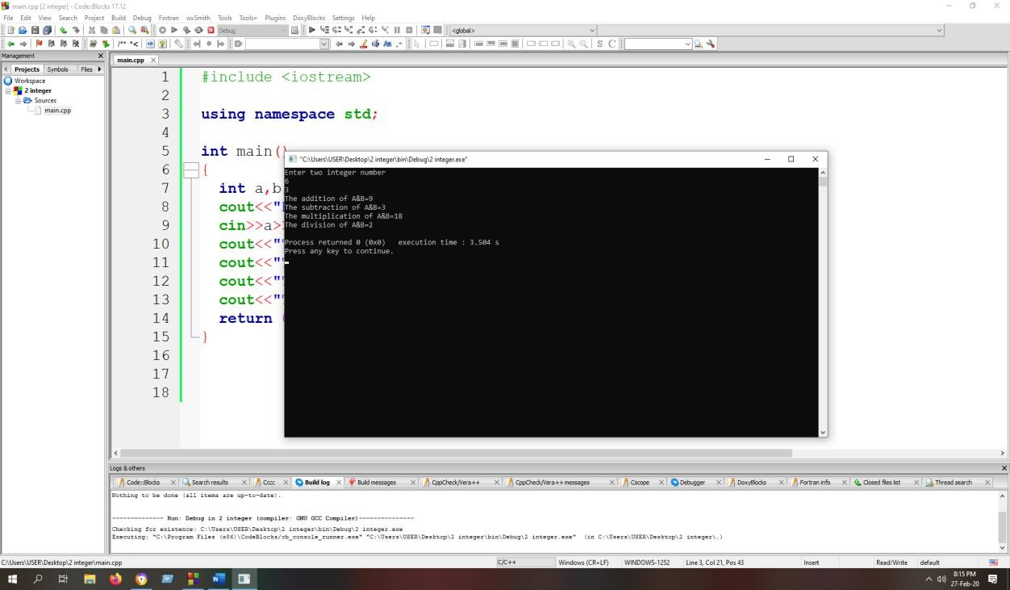

## A Program to swap two values:-

#include <iostream>

using namespace std;

int main()

{ int a,b,c;

cout<<"Enter two number for swap:"<<endl; cin>>a>>b;

cout<<"Before swap A="<<a<<endl; cout<<"Before swap B="<<b<<endl; c=a; a=b;

b=c;

cout<<"After swap A="<<a<<endl; cout<<"After swap B="<<b<<endl; return 0;

}

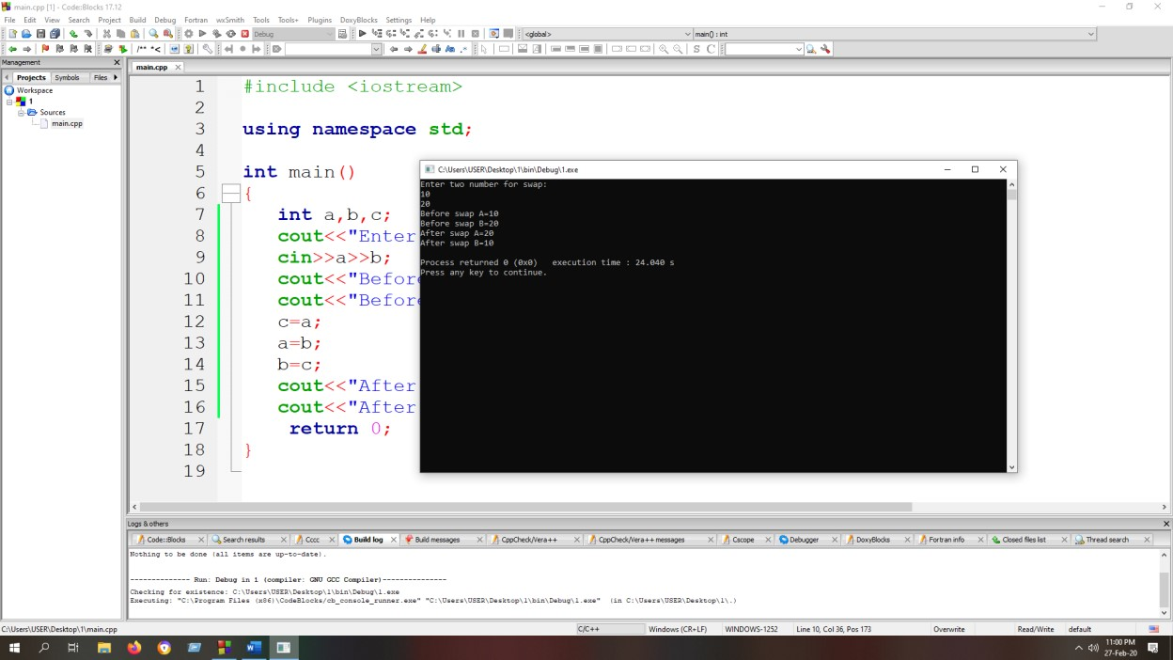

## A Program to convert two cities distance into different units:-

#include <iostream>

using namespace std;

int main()

{ int a;

cout<<"Enter the distance in k.m"<<endl; cin>>a;

cout<<"Distance in meter:"<<a*1000<<endl; cout<<"Distance in feet:"<<a*3280.84<<endl; cout<<"Distance in inche:"<<a*39370<<endl;

cout<<"Distance in centimeter:"<<a*100000<<endl; return 0;

}

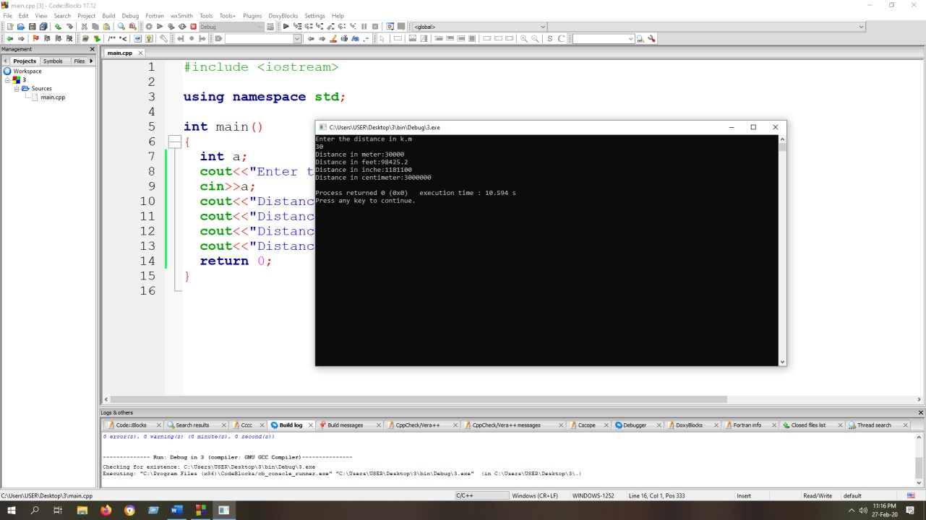

## A Program to calculate the sum of digits and the average:-

#include <iostream>

using namespace std;

int main()

{

int sum =0; int num=12345; while(num!=0){ sum=sum+num%10;

num=num/10;

}

cout<<"the sum is="<<sum<<endl;

cout<<"the average is="<<sum/5<<endl; return 0;

}

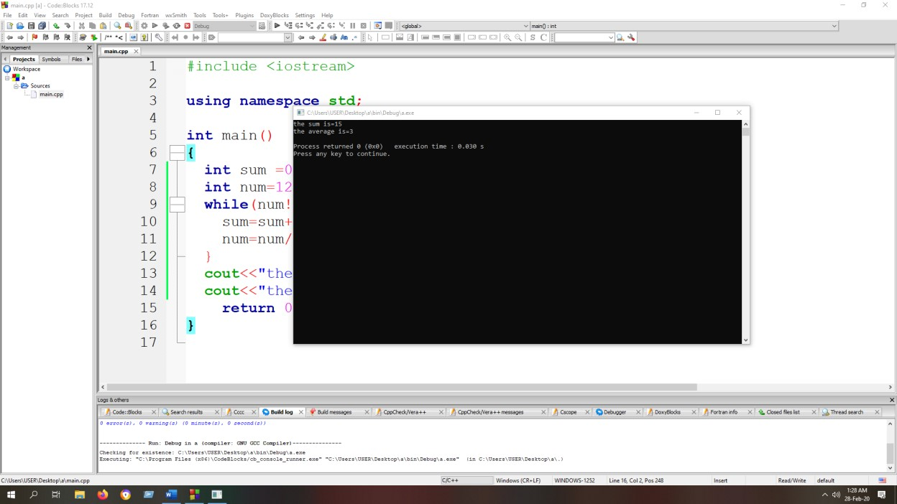

## A Program to find out an odd number or an even number:-

#include <iostream> using namespace std; int main()

{ int a;

cout<<"Enter an integer number"<<endl; cin>>a; if(a%2==0){

cout<<"it's a even number"<<a<<endl;

}

else

{

cout<<"it's a odd number"<<a<<endl;

}

return 0;

}

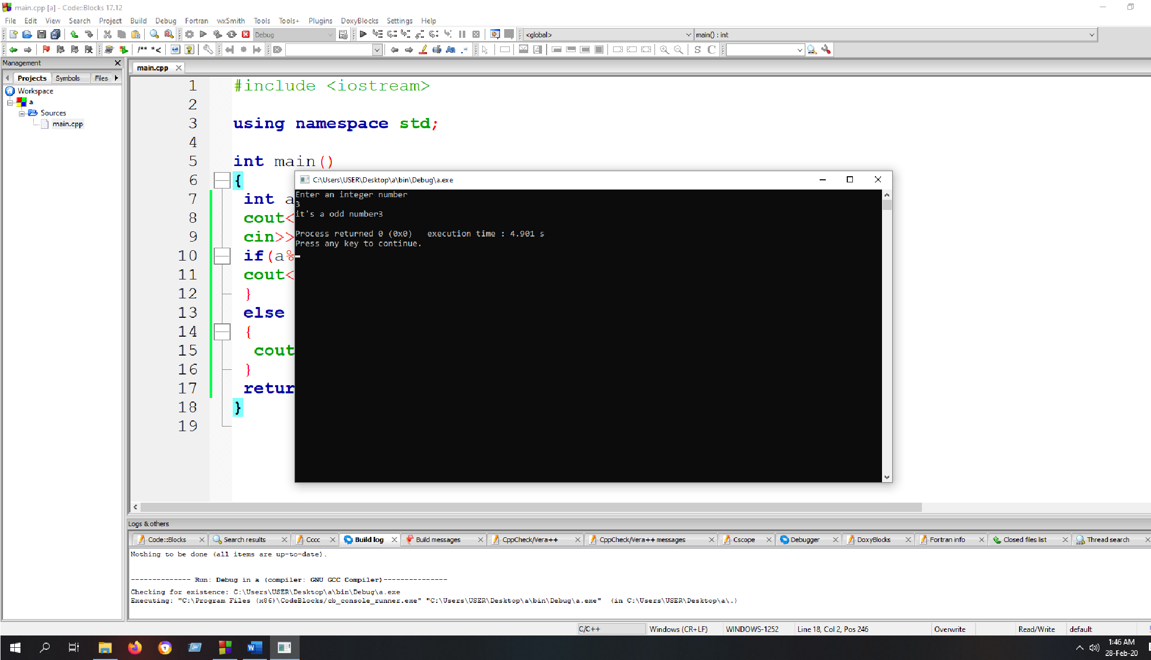

6. A Program to determine the year is leap year or not:-

#include <iostream> using namespace std; int main()

{ int year;

cout<<"Enter a year"<<endl; cin>>year; if(year%4==0){

cout<<"It's a leap year"<<endl;

}

else

{

cout<<"It's not a leap year"<<endl;

}

return 0;

}

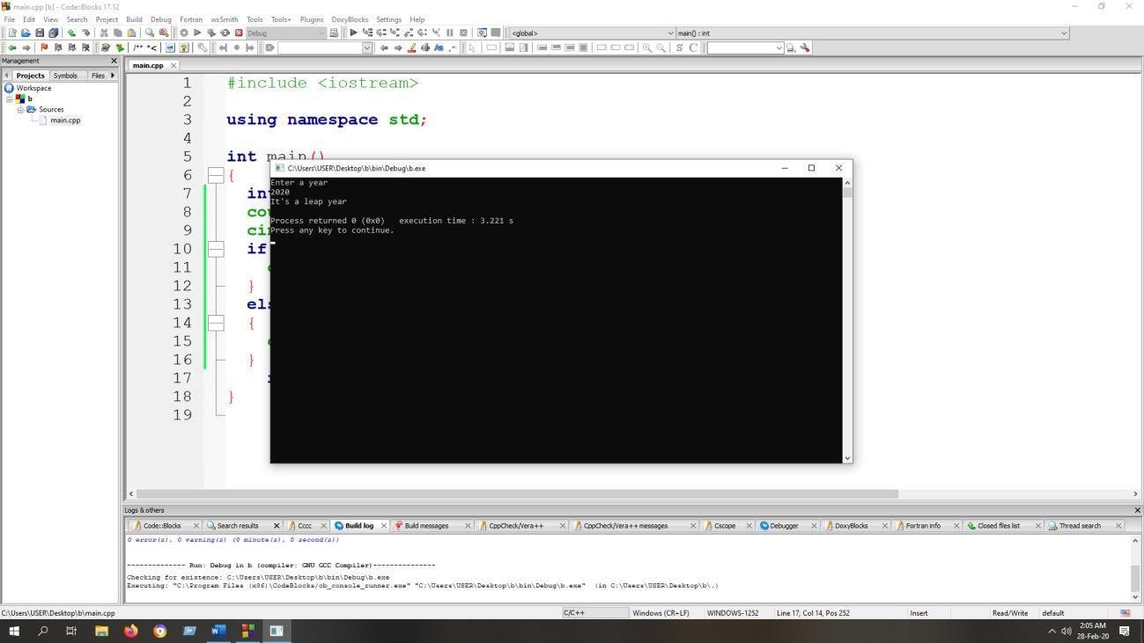

7.A Program to determine the youngest age:-

#include <iostream> using namespace std; int main()

{ inta; int b; int c;

cout<<"Age of Karim"<<endl; cin>>a;

cout<<"Age of Rahim"<<endl; cin>>b;

cout<<"Age of Jobber"<<endl; cin>>c; if(a<b&&a<c){

cout<<"Karim is younger"<<endl;

}

else if(b<a&&b<c){ cout<<"Rahim is younger"<<endl;

}

else{

cout<<"Jobber is younger"<<endl;

}

return 0;

}

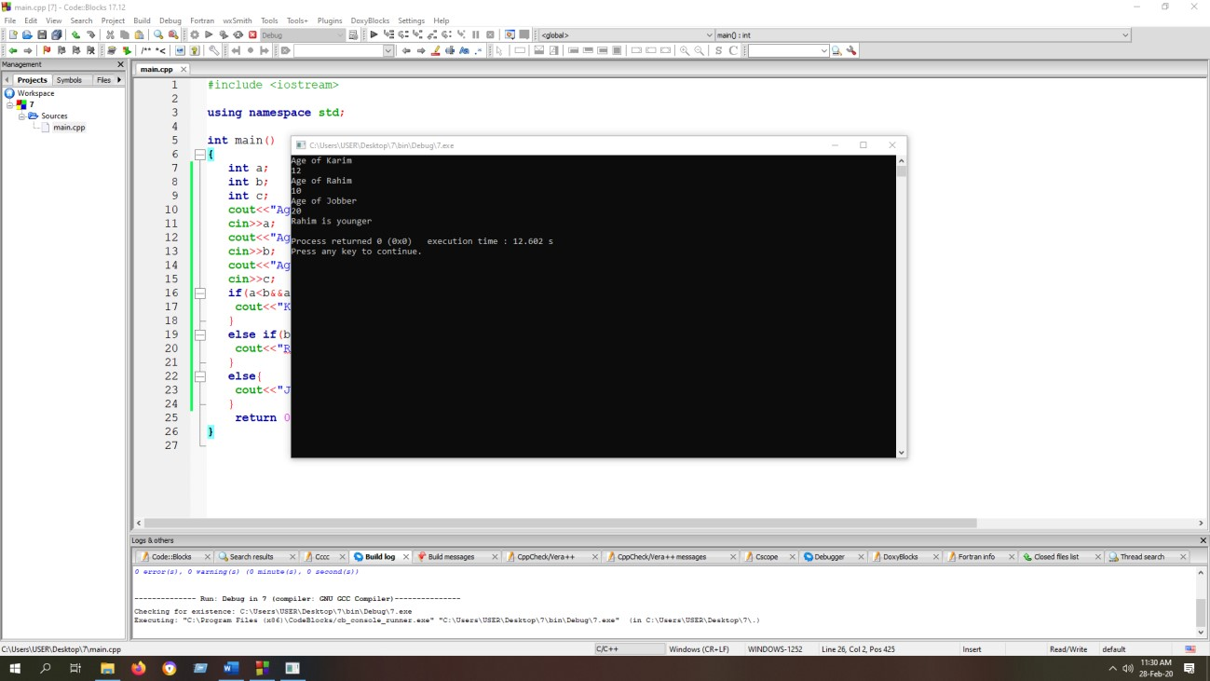

## 8.A Program to check whether a triangle is valid or not:-

#include <iostream> using namespace std; int main() {int a,b,c;

cout<<"Enter three angles of a triangle:"<<endl; cin>>a>>b>>c; if(a+b+c==180){

cout<<"The Triangle is valid"<<endl;

}

else{

cout<<"The Triangle is not valid"<<endl;

}

return 0;

}

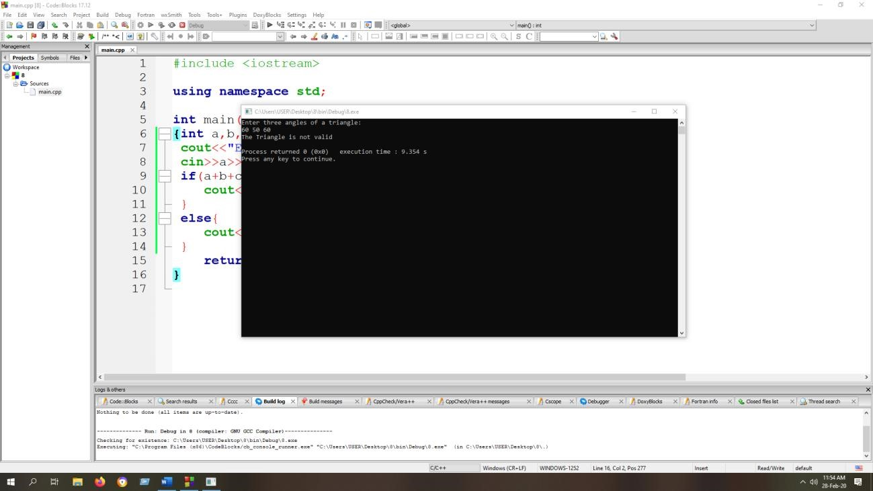

## 9.A Program to print the multiplication table:-

#include <iostream> using namespace std; int main()

{ int n;

cout<<"Enter a number"<<endl; cin>>n;

for(int a=1; a<=10; a++){ cout<<n<<"*"<<a<<"="<<n*a<<endl;

}

return 0;

}

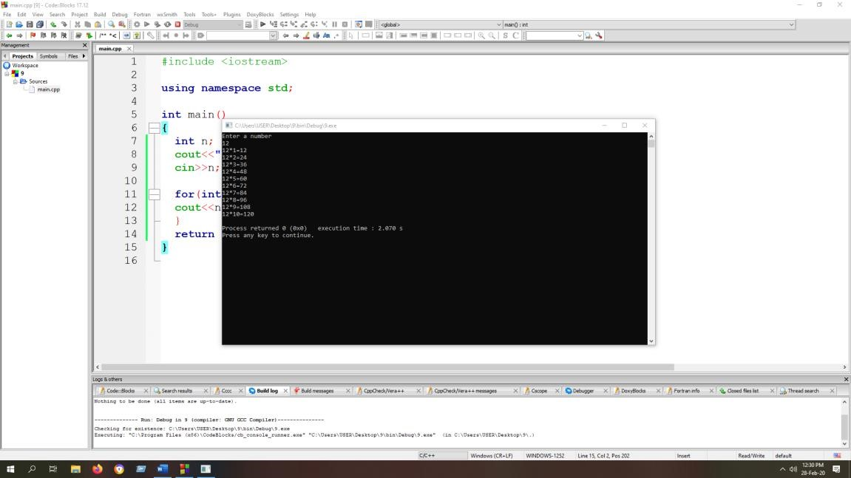

## 10.A Function which receives a float and an int from main() :-

#include <iostream>

using namespace std;

void product(){ float a;

cout<<"Enter a float number"<<endl;

cin>>a;

int b;

cout<<"Enter an integer number"<<endl; cin>>b;

float product=a*b;

cout<<"Product="<<product<<endl;

}

int main(){ product();

return 0;

}

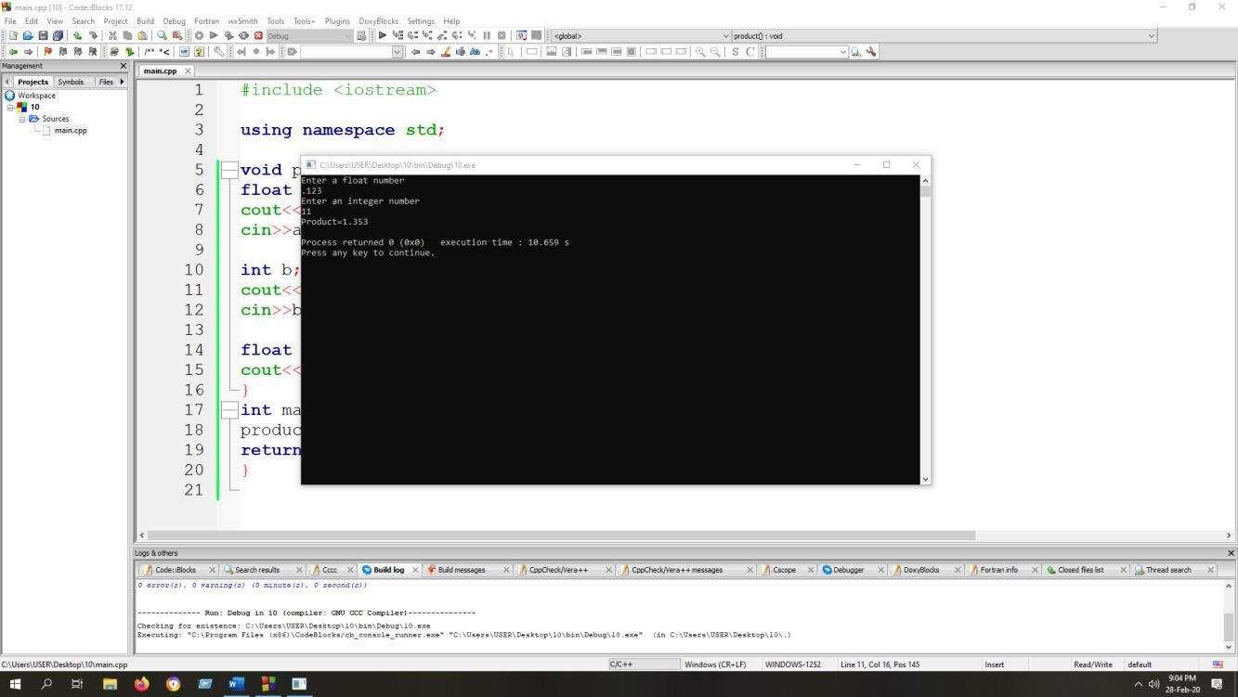

## 11.A Function that receives 5 integers and returns the sum,average:-

#include <iostream> using namespace std; void sum_and_average(){ int a; int b; int c; int d; int e;

cout<<"Enter five integers"<<endl; cin>>a>>b>>c>>d>>e; int sum=a+b+c+d+e; cout<<"sum="<<sum<<endl;

int avg=sum/5;

cout<<"Average="<<avg<<endl;

}

int main()

{

sum_and_average(); return 0;

}

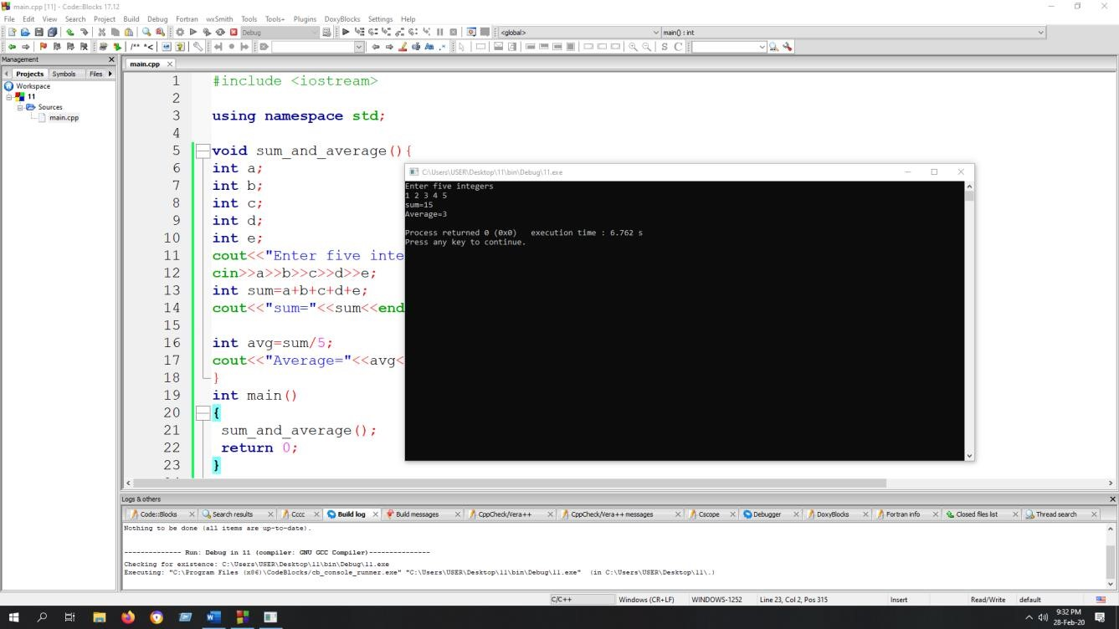

## 12.A Function to calculate the factorial value of any integer:-

#include <iostream> using namespace std;

int factorial(int n){ int fact=1; for(int i=1; i<=n; ++i){ fact*=i;

}

return fact;

}

int main(){ int n;

cout<<"Enter a number"<<endl; cin>>n; if(n<0){

cout<<"Factorial of a negative number doesn't exist"<<endl;

}

else{cout<<factorial(n);} return 0;

}

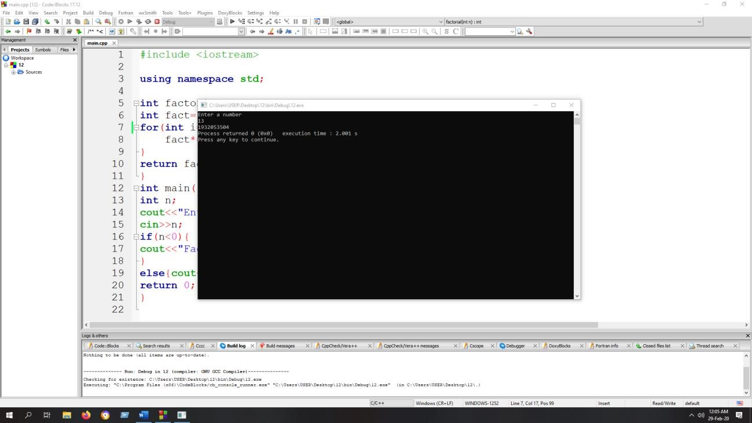

## 13. A Function to obtain the first 25 numbers of a Fibonakki sequence:-

#include <iostream> using namespace std; void fibonakki(){ int num,first=0, second=1, next;

cout <<"Enter the number for fibonakki series >>"<<endl; cin>>num;

cout<<"fibonakki series"<<endl; for(int i= 0; i<num; i++){ cout<<first<<endl; next=first + second; first= second; second= next;

}

}

int main(){ fibonakki(); return 0;

}

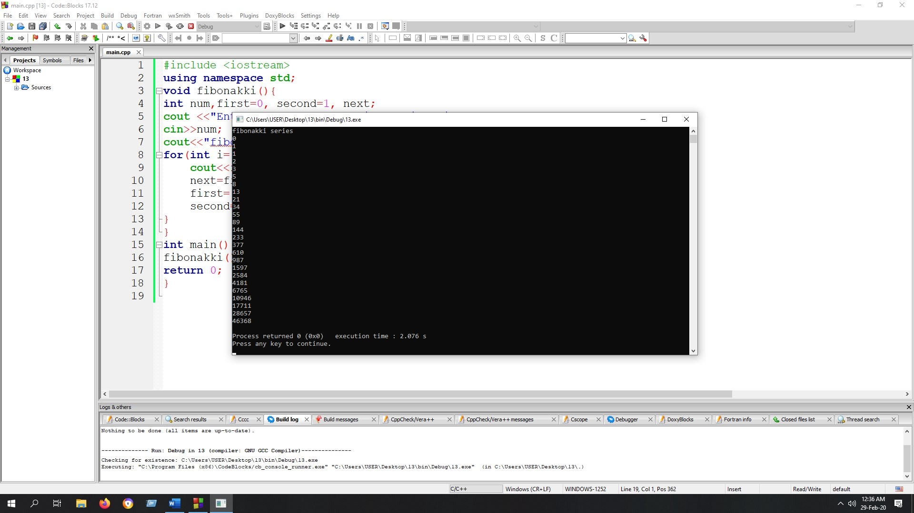

## 14. A Program that calculates the sum of the odd and even components of an array also calculate the average of odd and even components:-

#include <iostream> using namespace std; int main()

{

int num[5]={1,2,3,4,5}; int evenSum=0; int oddSum=0; int numOfeven=0; int numOfodd=0;

for(int i=0;i<=4;i++)

{

if(num[i]%2==0)

{

evenSum=evenSum+num[i]; numOfeven ++;

} else

{

oddSum=oddSum+num[i];

numOfodd ++;

}

}

cout<<"Sum of the even integers"<<evenSum<<endl; cout<<"Sum of the odd integers"<<oddSum<<endl; float evenAvg=(float)evenSum/numOfeven; float oddAvg=(float)oddSum/numOfodd; cout<<"Average of even:"<<evenAvg<<endl; cout<<"Average of odd:"<<oddAvg<<endl; return 0;

}

